|  |  |
| --- | --- |
|  | **2013** |
|  | Terry Woods |

|  |
| --- |
| **[ENTERPRISE CONSULTING WEB Design Document]** |
| This document contains design overviews for explaining and planning out designs for a website for a consulting business which is improving its marking strategy. |

ABOUT THE AUTHOR

Terry Woods is a web designer that grew up in Brooklyn, New York. At a young age he knew that he was interested in technology. Overtime, these interests grew into knowing about computer networking, digital forensics, and global enterprise technology. He is currently taking classes at the School of Information Studies at Syracuse University with a major in Information Management and Technology. After college, he plans on working for either the police department or FBI using his knowledge of computer security for digital forensics.

Table of Content

**Website Concept 3**

Purpose 3

Scope 3

Goals 3

Audience 4

General Overview of Website 5

**Visual Design 6**

Direction 6

Color Scheme 6

Typography 6

Imagery Discussion 7

**Mood Board 8**

**Site Architecture 9**

Sections 9

Description 10

Technology 10

**Estimated Cost 11**

Website Concept

**Purpose:**

The purpose of this Web Design Document is to provide a service to an information technology (I.T.) consulting business which deals with assisting companies and individual customers around the world with their technical problems. The document will be the blueprint for planning and implementing the website.

**Scope:**

This Web Design Document is for creating a usable website for customers and companies can use. The project was created to test an individual’s skills as a professional web designer. The service that will be produce to creating the website will be a function website which will have IT services.

**Goals:**

* Establish a fully functioning website
* Provide the business with a user friendly and professional/artistic environment
* Communication between the customers and the service(s) being provided
* Website that is simple to update and maintain without the original web designer

**Audience:**

The primary audience for this website is the customers and companies. The website must allow the customer to navigate the website smoothly. The customer will be able to find what they are looking for by using the menu provided in the website. This will allow them to find the service they need.

**Cases:**

The website will have two sections for:

* Customers- will have services and pricing based on individual need
* Companies-will have services and pricing based on the need on a global or area scale

Services will be provided are:

Support Services - This service will allow customers and companies to troubleshoot their technical problems with their business’s 24/7 helpdesk. The helpdesk will assist with their customers in three ways. The first will be by phone. The second is by email. The third is by the website helpdesk forum. If the problem cannot be fixed these methods, a representative will come to the location and fix the technical issue(s).

Virtualization – Buying computers are expensive. There is another solution. Virtualizing a person’s already existing computer saves money and decreases the customers or companies’ frustration of creating a complicated computer architecture system with different operating systems running on each computer.

Security Management- With technology growing at a fast rate, there is always a threat that will exploit vulnerabilities in software. The management system is a way to protect the vulnerabilities of the system. It will help customers and companies understand about backing up files and updating their software.

Computer Networking Services – Planning on creating or expanding your computer infrastructure? The IT consulting company can help whether it’s for one individual or a large company. Creating your own networks of computers will not be complicated. Just look at the different opinions on the website to see what you are looking for or you can customize a plan yourself.

**General Overview of Website:**

The website will provide customers with services that will allow them to find what they are looking for. It will also have a helpdesk in order to provide customers with additional information and troubleshooting solutions to problems that can occur on the website. The IT consulting company will also learn how to manage and update the website without the assistant of the original web designer for the website. Possible website link will be: http://tjwoods.mysite.syr.edu/globaldesignit

Visual Design

**Direction:**

The website will move away from the traditional or standard concept of the average IT consulting websites. Instead of the website looking like a business or corporation, it will have a more artistic look to the website. Having this artistic feel will allow customers to know that this website was created to inspire others while designing or implementing their own creativity with technology in some way or form. This is what will make the website unique and stand out from the rest of consulting websites.

**Color Scheme:**

The website will have cool colors. Having cool colors for the website will give the audience a realistic atmosphere while showing emotions of hope and excitement. Analogic colors will be the color scheme that will be used in creating the website. The colors being considered for the website is blue, green, and light blue. These colors bring out a natural environment for the website that will make the experience of going on the website interesting and unique. These colors will also help with customers with vision disabilities.

**Typography:**

The fonts being used for the website are Verdana and Lucida Console. The Verdana font will be used for heading and titles on each page. Lucida Console will be used for the content and paragraphs. The fonts are different from one another and will provide the website with a professional and creative look.

**Imagery Discussion:**

The website will use pictures that represent the IT architecture. For example, pictures of computers, switches, routers, etc. These will be used in different sections to show the different options available for each service. These pictures will found online and from Microsoft Visio and Cisco’s Packet Tracer. Cisco’s Packet Tracer and Microsoft Visio will be especially used to show the different options that the computer networking service will provide. It will show the customers what they are looking without reading a lot of text and being confused by the technical details.

Mood Board



This is the mood board which will be used to for the website design.

Site Architecture

**Sections:**

The website will have about four sections for the menu:

* Home (return to and back to the page)
* IT Consulting (will have four different sections: Support Services, Virtualization, Security Management, and Computer Networking Services )
* About us (will have information about the history of the company)
* Contact (will have the contact information for the company)

**Description:**

The menu will be located at the top of the website for all to see. The sections for the menus will be located on top of each web page. The only folder (menu) that will have more than one level of folders will be the IT Consultanting folder. This will allow customers to find what they are l looking for without going into different areas of the website. It is a simple navigation that anyone can use without the information being complex. 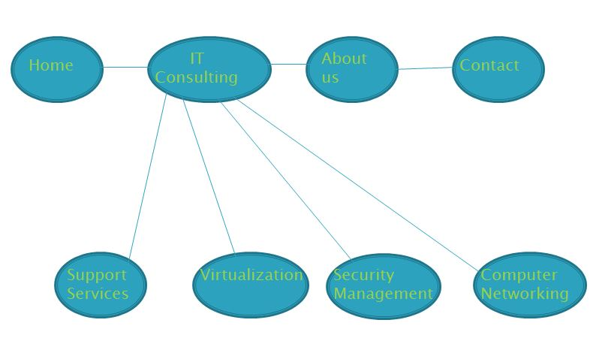

**Technology:**

The website will be built in HTML5 using CSS and jQuery. The CSS file will be used to set the background and overall design of the website. It will take care of the color, fonts, and box model structure of the website. The jQuery file will take care of the effects of the website. It will be used to drop menu items for navigating the website. The website will have other effects like a slide show feature which will show graphical designs in a professional atmosphere.

Estimated Cost

**Hourly Web Design:**

Creating a website with all of these elements will take time to implement. I have estimate the time that will be taken for completing the website, finding major issues with the design, and letting a person test out the website and give their opinion about it. The website will take about a week to complete. Finding major issues in the website like the effects of jQuery are not functioning correctly will take about three to four days to correct. Letting a person test out the website will only two days. As the web designer for this website, I will be taking about five to six hours a day to complete the website and would like to be charged $70 to $90 an hour for my work. The overall cost for the website should be about $4,550 to $7,020.